

DEPARTMENT OF INFORMATION TECHNOLOGY
24ITT32 – PROGRAMMING IN JAVA
INDIVIDUAL PROJECT ON
ACADEMIC MANAGEMENT SYSTEM
PROJECT REPORT
Submitted by
YOGESHWARAN V
25ITR181

JAVA ASSIGNMENT

AIM

To design and implement a Menu-Driven Student Academic and Continuous Evaluation System using Java JDBC and MySQL, adhering to Kongu Engineering College Regulation 2024 (R2024) academic evaluation rules, including phased marks entry, attendance eligibility enforcement, KEC 10-point grading, SGPA computation, and automated academic report generation.

OBJECTIVE

To design and develop a database-driven Java application using JDBC to manage student records, perform incremental marks entry (Continuous Internal Assessments and End Semester Examinations), enforce attendance eligibility rules, and generate formal academic performance reports according to Kongu Engineering College (Autonomous) – Regulation 2024.

FLOW CHART:
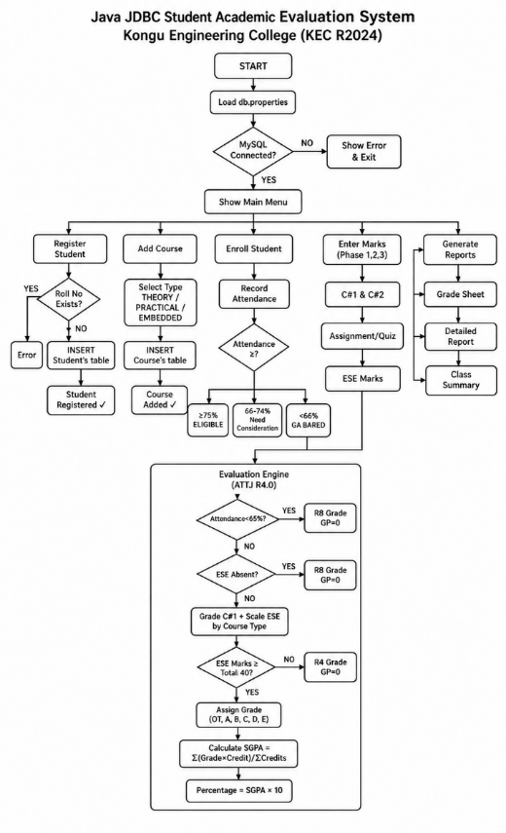

PROCEDURE
- Load the MySQL Connector/J driver using Class.forName() inside the DBConnection class to enable communication between the Java application and the MySQL database.
- Establish a connection to the kec_eval_db database using DriverManager.getConnection(), reading credentials from the db.properties file with automatic port fallback support.
- Store and retrieve student details (roll number, name, department, semester) and course details (code, title, credits, type) using StudentDAO and AcademicDAO with parameterized SQL statements.
- Enroll students in semester courses, record classes conducted and attended, and calculate the attendance percentage stored in the enrollments table.
- Verify ESE eligibility based on attendance: ≥75% eligible, 65–74.9% requires Medical Condonation, and <65% is barred and awarded grade SA (0 grade points) per KEC R2024 Clause 7.
- Record CIA-1, CIA-2, and Assignment marks in three phases and compute Raw CIA using: CIA = (CIA1 × 0.40) + (CIA2 × 0.40) + (Assignment × 0.20), then scale by course type.
- Record ESE marks out of 100, verify minimum passing thresholds (45% for Theory/Embedded, 50% for Practical), and scale according to course weightage.
- Combine scaled CIA and ESE to get total marks, assign letter grades and grade points using the KEC 10-point grading scale, and compute SGPA and Equivalent Percentage.
- Generate Student Grade Sheets, Attendance Defaulter Reports, and Department-wise Performance Summaries and display all results through the command-line console.

DATABASE SCHEMA

1. Students Table
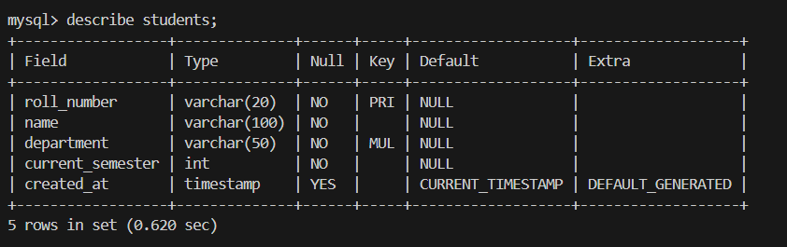

2. Courses Table
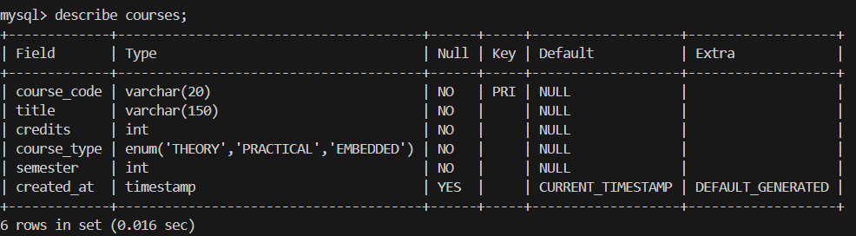

3. Enrollments Table
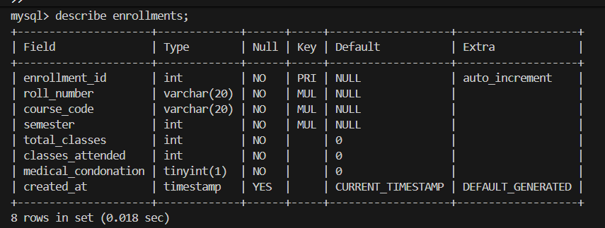

4. Assessment Marks Table
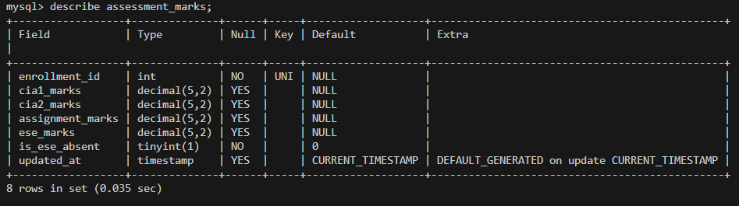

SOURCE CODE

MainApp.java
package com.kec;
import com.kec.dao.AcademicDAO;
import com.kec.dao.StudentDAO;
import com.kec.db.DBConnection;
import com.kec.model.*;
import com.kec.service.EvaluationEngine;
import com.kec.util.ReportGenerator;
import java.sql.SQLException;
import java.util.List;
import java.util.Scanner;

public class MainApp {
private static final StudentDAO studentDAO=new StudentDAO();
private static final AcademicDAO academicDAO=new AcademicDAO();
private static final Scanner scanner=new Scanner(System.in);

public static void main(String[] args) {
if(args.length>0&&(args[0].equalsIgnoreCase("--demo")||args[0].equalsIgnoreCase("-d"))){runAutomatedDemonstration();return;}
printBanner();checkDatabaseConnectivity();boolean running=true;
while(running){
printMainMenu();String choice=readInput("Select an option (0-13): ");
try{
switch(choice.trim()){
case "1" -> registerStudent();
case "2" -> viewAllStudents();
case "3" -> addCourse();
case "4" -> viewCourseCatalog();
case "5" -> enrollStudentInCourse();
case "6" -> updateAttendanceAndCondonation();
case "7" -> recordPhase1Cia();
case "8" -> recordPhase2Assignment();
case "9" -> recordPhase3Ese();
case "10" -> generateStudentMarkSheet();
case "11" -> generateAttendanceDefaulterReport();
case "12" -> generateClassPerformanceSummary();
case "13" -> runAutomatedDemonstration();
case "0" -> {System.out.println("Exiting KEC R2024 Evaluation System.");running=false;}
default -> System.out.println("Invalid selection.");
}
}catch(Exception e){System.err.println("[ERROR] "+e.getMessage());}
if(running){System.out.println("Press Enter to continue...");scanner.nextLine();}
}
}

private static void printBanner(){
System.out.println("KONGU ENGINEERING COLLEGE - R2024");
System.out.println("STUDENT ACADEMIC & CONTINUOUS EVALUATION SYSTEM");
}

private static void checkDatabaseConnectivity(){
System.out.println(DBConnection.testConnection()?"Database Connected: "+DBConnection.getActiveUrl():"Database Connection Failed");
}

private static void printMainMenu(){
System.out.println("""
===== MAIN MENU =====
1. Register Student
2. View Students
3. Add Course
4. View Courses
5. Enroll Student
6. Update Attendance
7. Enter CIA Marks
8. Enter Assignment Marks
9. Enter ESE Marks
10. Student Mark Sheet
11. Attendance Defaulters
12. Class Performance
13. Automated Demo
0. Exit
""");
}

private static void registerStudent() throws SQLException{
String roll=readInput("Roll Number: ").toUpperCase();
if(studentDAO.getStudentByRollNumber(roll)!=null){System.out.println("Student already exists.");return;}
Student s=new Student(roll,readInput("Name: "),readInput("Department: ").toUpperCase(),readIntInput("Semester: ",1,8));
System.out.println(studentDAO.addStudent(s)?"Student registered: "+s:"Registration failed.");
}

private static void viewAllStudents() throws SQLException{
List<Student> list=studentDAO.getAllStudents();
if(list.isEmpty()){System.out.println("No students found.");return;}
for(Student s:list)System.out.printf("%s | %s | %s | Sem %d%n",s.getRollNumber(),s.getName(),s.getDepartment(),s.getCurrentSemester());
System.out.println("Total Students: "+list.size());
}

private static void addCourse() throws SQLException{
String code=readInput("Course Code: ").toUpperCase();
if(academicDAO.getCourse(code)!=null){System.out.println("Course already exists.");return;}
String title=readInput("Course Title: ");
int credits=readIntInput("Credits: ",1,6);
System.out.println("1.THEORY 2.PRACTICAL 3.EMBEDDED");
int t=readIntInput("Course Type: ",1,3);
CourseType type=switch(t){case 2->CourseType.PRACTICAL;case 3->CourseType.EMBEDDED;default->CourseType.THEORY;};
Course c=new Course(code,title,credits,type,readIntInput("Semester: ",1,8));
System.out.println(academicDAO.addCourse(c)?"Course added: "+c:"Course addition failed.");
}

private static void viewCourseCatalog() throws SQLException{
List<Course> list=academicDAO.getAllCourses();
if(list.isEmpty()){System.out.println("No courses found.");return;}
for(Course c:list)System.out.printf("%s | %s | %d | %s | Sem %d%n",c.getCourseCode(),c.getTitle(),c.getCredits(),c.getCourseType().getDisplayName(),c.getSemester());
System.out.println("Total Courses: "+list.size());
}

private static void enrollStudentInCourse() throws SQLException{
String roll=readInput("Student Roll Number: ").toUpperCase();
if(studentDAO.getStudentByRollNumber(roll)==null){System.out.println("Student not found.");return;}
String code=readInput("Course Code: ").toUpperCase();
if(academicDAO.getCourse(code)==null){System.out.println("Course not found.");return;}
int sem=readIntInput("Semester: ",1,8);
if(academicDAO.getEnrollment(roll,code,sem)!=null){System.out.println("Already enrolled.");return;}
int total=readIntInput("Total Classes: ",0,200),attended=readIntInput("Attended Classes: ",0,total);
boolean cond=readInput("Medical Condonation Approved? (Y/N): ").equalsIgnoreCase("Y");
int id=academicDAO.enrollStudent(roll,code,sem,total,attended,cond);
if(id>0){
double pct=total>0?attended*100.0/total:0;
System.out.printf("Enrolled ID %d; Attendance %.1f%%%n",id,pct);
if(pct<65)System.out.println("Attendance shortage: SA.");
else if(pct<75&&!cond)System.out.println("Medical condonation required.");
}
}

private static void updateAttendanceAndCondonation() throws SQLException{
String roll=readInput("Roll Number: ").toUpperCase(),code=readInput("Course Code: ").toUpperCase();
int sem=readIntInput("Semester: ",1,8);
Enrollment en=academicDAO.getEnrollment(roll,code,sem);
if(en==null){System.out.println("Enrollment not found.");return;}
System.out.printf("Attendance: %d/%d (%.1f%%)%n",en.getClassesAttended(),en.getTotalClasses(),en.getAttendancePercentage());
int total=readIntInput("Total Classes: ",0,200),attended=readIntInput("Attended Classes: ",0,total);
boolean cond=readInput("Approve Condonation? (Y/N): ").equalsIgnoreCase("Y");
academicDAO.updateAttendance(en.getEnrollmentId(),total,attended);
academicDAO.setMedicalCondonation(en.getEnrollmentId(),cond);
System.out.println("Attendance updated.");
}

private static Enrollment getEnrollment() throws SQLException{
String roll=readInput("Roll Number: ").toUpperCase(),code=readInput("Course Code: ").toUpperCase();
Enrollment en=academicDAO.getEnrollment(roll,code,readIntInput("Semester: ",1,8));
if(en==null)System.out.println("Enrollment not found.");
return en;
}

private static void recordPhase1Cia() throws SQLException{
Enrollment en=getEnrollment();if(en==null)return;
double a=readDoubleInput("CIA 1 Marks: ",0,100),b=readDoubleInput("CIA 2 Marks: ",0,100);
System.out.println(academicDAO.recordPhase1Marks(en.getEnrollmentId(),a,b)?"CIA marks saved.":"Failed.");
}

private static void recordPhase2Assignment() throws SQLException{
Enrollment en=getEnrollment();if(en==null)return;
double a=readDoubleInput("Assignment/Quiz/Lab Marks: ",0,100);
if(academicDAO.recordPhase2Marks(en.getEnrollmentId(),a)){
AssessmentMark m=academicDAO.getAssessmentMark(en.getEnrollmentId());
Double cia=EvaluationEngine.calculateRawCia100(m.getCia1Marks(),m.getCia2Marks(),m.getAssignmentMarks());
System.out.printf("Phase 2 saved. Raw CIA: %.2f%n",cia!=null?cia:a);
}else System.out.println("Failed to save marks.");
}

private static void recordPhase3Ese() throws SQLException{
Enrollment en=getEnrollment();if(en==null)return;
if(!en.isAttendanceEligibleForEse()){
System.out.println("Student barred from ESE: "+en.getAttendanceStatusLabel());
if(!readInput("Continue anyway? (Y/N): ").equalsIgnoreCase("Y"))return;
}
if(readInput("Absent? (Y/N): ").equalsIgnoreCase("Y")){
academicDAO.recordPhase3Marks(en.getEnrollmentId(),null,true);
System.out.println("Student marked absent (AB).");return;
}
double marks=readDoubleInput("ESE Marks: ",0,100);
if(academicDAO.recordPhase3Marks(en.getEnrollmentId(),marks,false)){
EvaluationResult r=EvaluationEngine.evaluateEnrollment(en,academicDAO.getCourse(readInput("Course Code: ").toUpperCase()),academicDAO.getAssessmentMark(en.getEnrollmentId()));
System.out.printf("Total: %.1f | Grade: %s | GP: %d | %s%n",r.getTotalMarks(),r.getGrade().getLetter(),r.getGradePoint(),r.isPass()?"PASS":r.getRemarks());
}
}

private static void generateStudentMarkSheet() throws SQLException{
String roll=readInput("Student Roll Number: ").toUpperCase();
Student s=studentDAO.getStudentByRollNumber(roll);
if(s==null){System.out.println("Student not found.");return;}
int sem=readIntInput("Semester: ",1,8);
System.out.println(ReportGenerator.generateStudentMarkSheet(s.getRollNumber(),s.getName(),s.getDepartment(),sem,academicDAO.evaluateStudentSemester(roll,sem)));
}

private static void generateAttendanceDefaulterReport() throws SQLException{
System.out.println(ReportGenerator.generateAttendanceDefaulterReport(academicDAO.getAttendanceDefaulters()));
}

private static void generateClassPerformanceSummary() throws SQLException{
String dept=readInput("Department: ").toUpperCase();
int sem=readIntInput("Semester: ",1,8);
List<String> rolls=academicDAO.getStudentRollNumbersByDeptAndSem(dept,sem);
if(rolls.isEmpty()){System.out.println("No students found.");return;}
int pass=0,fail=0;double sum=0;
for(String roll:rolls){
List<EvaluationResult> results=academicDAO.evaluateStudentSemester(roll,sem);
if(!results.isEmpty()&&results.stream().allMatch(EvaluationResult::isPass))pass++;else fail++;
sum+=EvaluationEngine.calculateSgpa(results);
}
System.out.println(ReportGenerator.generateClassPerformanceSummary(dept,sem,rolls.size(),pass,fail,sum/rolls.size()));
}

public static void runAutomatedDemonstration(){
try{
String roll="24ITR099",code="24ITR39";
if(studentDAO.getStudentByRollNumber(roll)==null)studentDAO.addStudent(new Student(roll,"Suresh Kumar V","IT",3));
if(academicDAO.getCourse(code)==null)academicDAO.addCourse(new Course(code,"Cloud Computing Principles",3,CourseType.THEORY,3));
if(academicDAO.getEnrollment(roll,code,3)==null)academicDAO.enrollStudent(roll,code,3,50,45,false);
Enrollment en=academicDAO.getEnrollment(roll,code,3);
academicDAO.recordPhase1Marks(en.getEnrollmentId(),88,92);
academicDAO.recordPhase2Marks(en.getEnrollmentId(),90);
academicDAO.recordPhase3Marks(en.getEnrollmentId(),86,false);
System.out.println("Automated demonstration completed.");
System.out.println(ReportGenerator.generateAttendanceDefaulterReport(academicDAO.getAttendanceDefaulters()));
}catch(Exception e){System.err.println("Demo error: "+e.getMessage());}
}

private static String readInput(String p){System.out.print(p);return scanner.nextLine().trim();}

private static int readIntInput(String p,int min,int max){
while(true)try{
System.out.print(p);int n=Integer.parseInt(scanner.nextLine().trim());
if(n>=min&&n<=max)return n;
System.out.printf("Enter a value from %d to %d.%n",min,max);
}catch(NumberFormatException e){System.out.println("Invalid integer.");}
}

private static double readDoubleInput(String p,double min,double max){
while(true)try{
System.out.print(p);double n=Double.parseDouble(scanner.nextLine().trim());
if(n>=min&&n<=max)return n;
System.out.printf("Enter a value from %.1f to %.1f.%n",min,max);
}catch(NumberFormatException e){System.out.println("Invalid number.");}
}
}

DBConnection.java
package com.kec.db;

import java.io.File;
import java.io.FileInputStream;
import java.io.InputStream;
import java.sql.Connection;
import java.sql.DriverManager;
import java.sql.SQLException;
import java.util.Properties;

/**
* DBConnection - JDBC Connection Manager for KEC Evaluation System.
* Manages database driver registration, connection pooling/acquisition,
* configuration loading, and diagnostic fallback.
*/
public class DBConnection {

private static String url;
private static String user;
private static String password;
private static String driver;

static {
loadConfiguration();
}

private static void loadConfiguration() {
Properties props = new Properties();
boolean loaded = false;

// 1. Try loading from working directory db.properties
File file = new File("db.properties");
if (file.exists()) {
try (FileInputStream fis = new FileInputStream(file)) {
props.load(fis);
loaded = true;
} catch (Exception ignored) {
}
}

// 2. Try loading from classpath
if (!loaded) {
try (InputStream is = DBConnection.class.getResourceAsStream("/db.properties")) {
if (is != null) {
props.load(is);
loaded = true;
}
} catch (Exception ignored) {
}
}

// 3. Set properties with robust defaults
url = props.getProperty("db.url",
"jdbc:mysql://localhost:3307/kec_eval_db?useSSL=false&allowPublicKeyRetrieval=true&serverTimezone=Asia/Kolkata");
user = props.getProperty("db.user", "root");
password = props.getProperty("db.password", "");
driver = props.getProperty("db.driver", "com.mysql.cj.jdbc.Driver");

try {
Class.forName(driver);
} catch (ClassNotFoundException e) {
System.err.println("[WARN] MySQL Driver not found on classpath: " + e.getMessage());
}
}
public static Connection getConnection() throws SQLException {
try {
return DriverManager.getConnection(url, user, password);
} catch (SQLException primaryEx) {
// If configured on 3307 and failed, attempt fallback to 3306
if (url.contains(":3307")) {
String altUrl = url.replace(":3307", ":3306");
try {
Connection altConn = DriverManager.getConnection(altUrl, user, password);
url = altUrl; // update url to functioning port
return altConn;
} catch (SQLException ignored) {
}
}
throw primaryEx;
}
}

/**
* Verifies whether the database is accessible.
*/
public static boolean testConnection() {
try (Connection conn = getConnection()) {
return conn != null && !conn.isClosed();
} catch (Exception e) {
return false;
}
}

public static String getActiveUrl() {
return url;
}

public static String getUser() {
return user;
}

public static void setCredentials(String newUrl, String newUser, String newPass) {
url = newUrl;
user = newUser;
password = newPass;
}

public static void close(AutoCloseable resource) {
if (resource != null) {
try {
resource.close();
} catch (Exception ignored) {
}
}
}
}

OUTPUT SCREENSHOTS

Main Menu
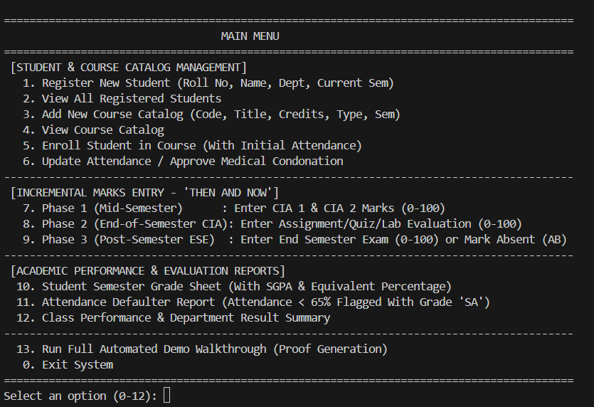

Student & Course Management

Student Registration
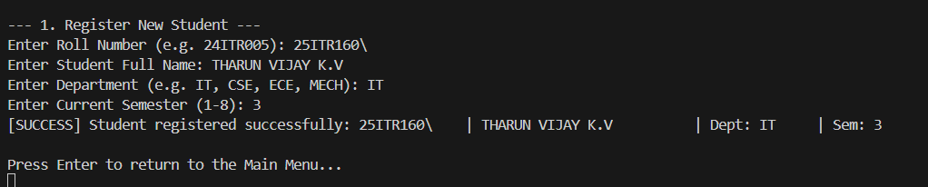

Course Catalog
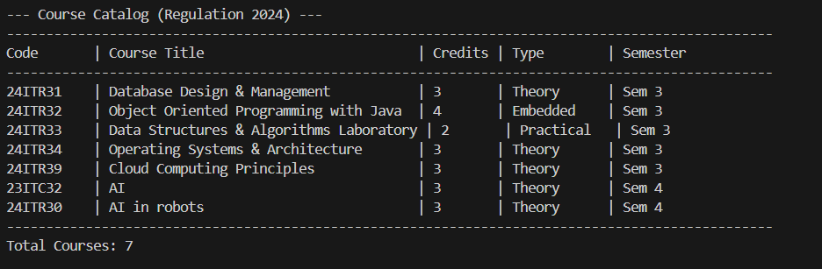

Course Enrollment & Attendance Tracking
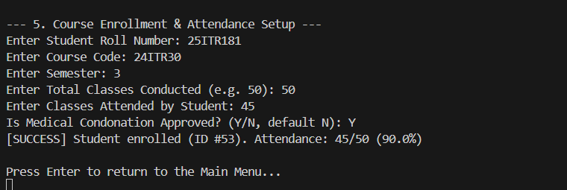

Incremental Marks Entry

Phase 1 (Mid-Semester)
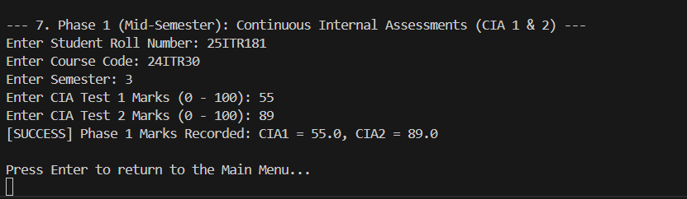

Phase 2 (End of Semester – CIA)
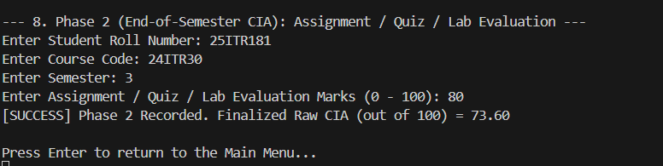

Phase 3 (Post Semester)
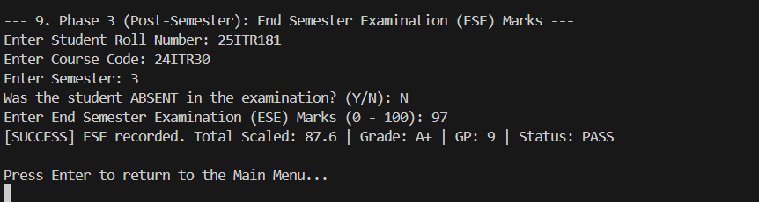

Attendance & Grading Rules

Attendance Filter
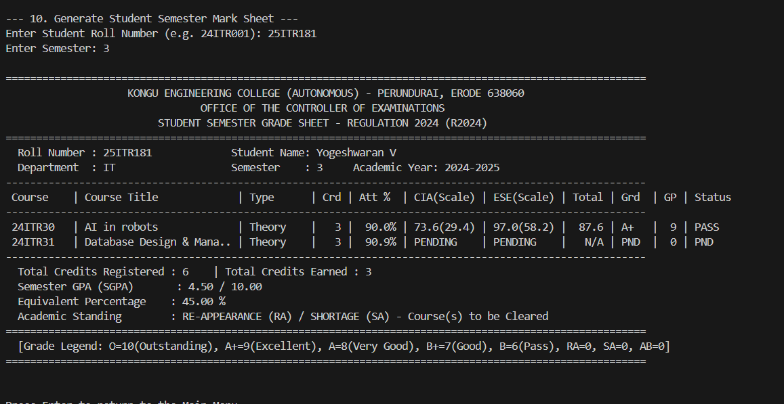

Student Semester Mark Sheet
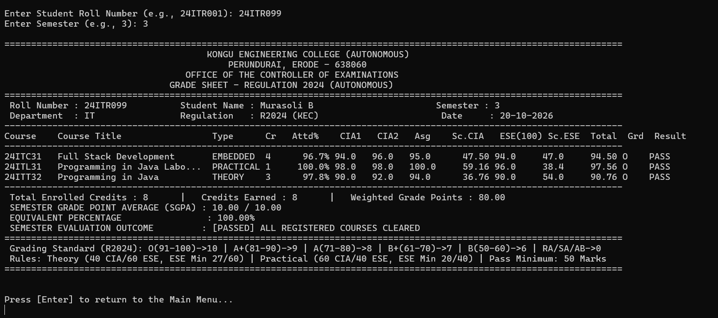

Department-Wise Class Performance & Result Summary
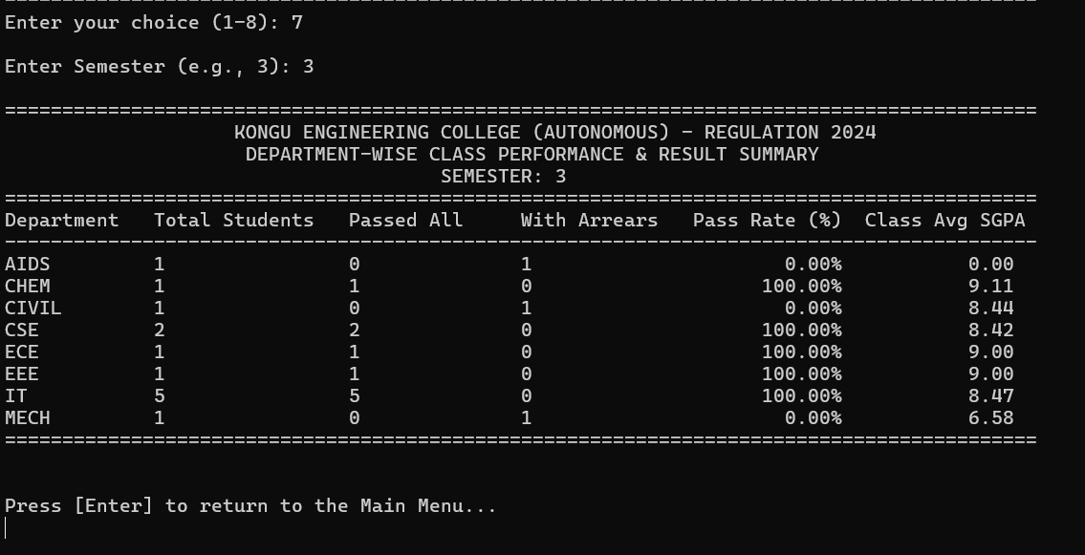

DATABASE

Students Database
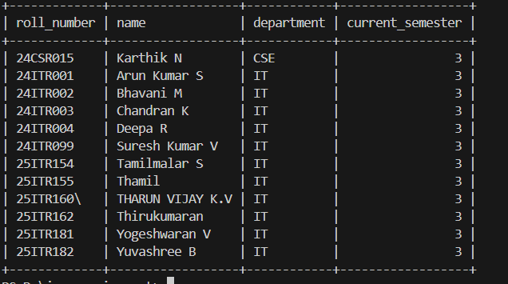

Courses Database
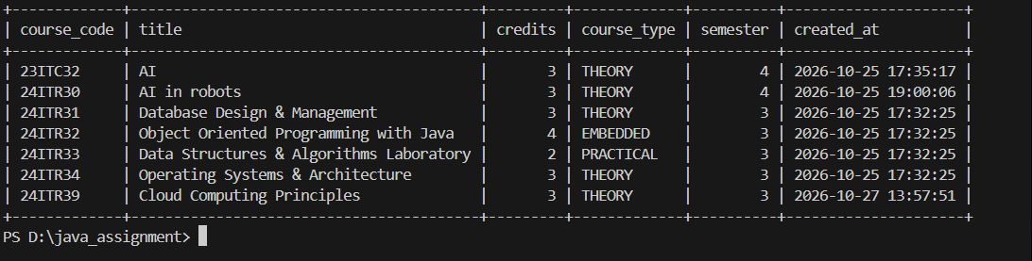

Enrollments Database
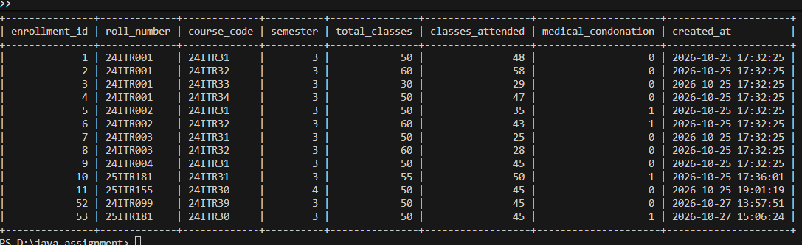

RESULT
The KEC Student Academic Evaluation System was successfully implemented using Java JDBC and MySQL. Student registration, course enrollment, attendance verification, phased marks entry, grade computation, SGPA calculation, and academic report generation were all executed correctly, validating full compliance with Kongu Engineering College Regulation 2024.

REFERENCES
- Oracle Corporation, "Java JDBC Documentation," Oracle Java SE 21, 2024. [Online]. Available: https://docs.oracle.com/en/java/javase/21/docs/api/java.sql/java/sql/package-summary.html
- Oracle Corporation, "MySQL 8.0 Reference Manual," MySQL Documentation, 2024. [Online]. Available: https://dev.mysql.com/doc/refman/8.0/en/
- MySQL Connector/J, "MySQL Connector/J Developer Guide," 2024. [Online]. Available: https://dev.mysql.com/doc/connector-j/en/
- Oracle Corporation, "DriverManager — Java SE 21 API," 2024. [Online]. Available: https://docs.oracle.com/en/java/javase/21/docs/api/java.sql/java/sql/DriverManager.html
- Apache Maven, "Maven Build Tool Documentation," 2024. [Online]. Available: https://maven.apache.org/guides/index.html
- Kongu Engineering College, "KEC Official Website," 2024. [Online]. Available: https://www.kongu.edu
- GeeksforGeeks, "JDBC Tutorial," 2024. [Online]. Available: https://www.geeksforgeeks.org/introduction-to-jdbc/
- Tutorialspoint, "Java MySQL JDBC Tutorial," 2024. [Online]. Available: https://www.tutorialspoint.com/jdbc/index.htm
- Oracle Corporation, “Java Platform, Standard Edition Documentation,” Oracle, 2024. [Online]. Available: https://docs.oracle.com/en/java/javase/21/
- Oracle Corporation, “JDBC Basics,” The Java Tutorials, 2024. [Online]. Available: https://docs.oracle.com/javase/tutorial/jdbc/basics/

GITHUB
Repository Link: https://github.com/Yogeshwaran-11/kec-academic-evaluation-system

